



**ПОЧЕМУ таймер включается сразу?**

В функции TIM_TimeBaseInit(TIMx, &timer) :



Значение PSC обновляется при прерывании. Чтобы в таймере оказалось это значение наверняка, вызывается прерывание «в ручную» с помощью регистра EGR.  
Чтобы побороть это безобразие нужно очистить флаг запроса в NVIC с помощью ICPR:





**Приоритеты**

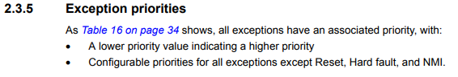

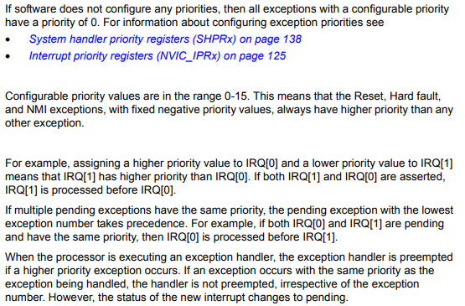

(ProgMan p. 36-37)

A lower priority value indicating a higher priority.

Configurable priorities for all exceptions except Reset, Hard fault, and NMI.

If software does not configure any priorities, then all exceptions with a configurable priority have a priority of 0.

If multiple pending exceptions have the same priority, the pending exception with the lowest exception number takes precedence. If both IRQ[0] and IRQ[1] are pending and have the same priority, then IRQ[0] is processed before IRQ[1].

When the processor is executing an exception handler, the exception handler is preempted if a higher priority exception occurs. If an exception occurs with the same priority as the exception being handled, the handler is not preempted, irrespective of the exception number. However, the status of the new interrupt changes to pending.

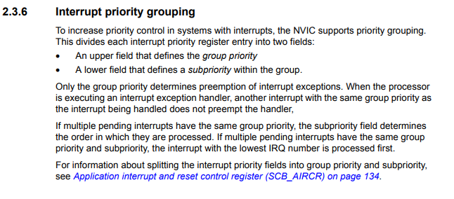

(ProgMan p. 37)

Only the group priority determines preemption of interrupt exceptions.

If multiple pending interrupts have the same group priority, the subpriority field determines the order in which they are processed.

If multiple pending interrupts have the same group priority and subpriority, the interrupt with the lowest IRQ number is processed first.

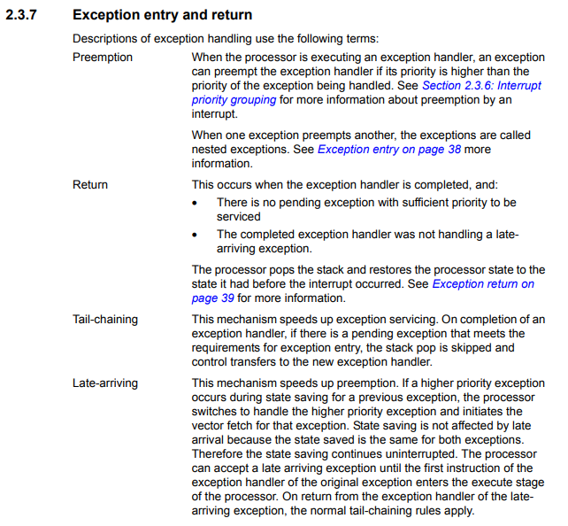

(ProgMan p. 38)

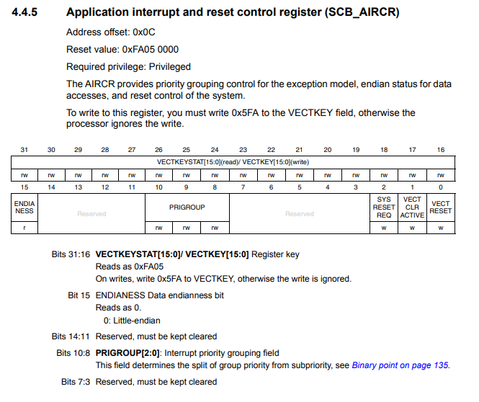

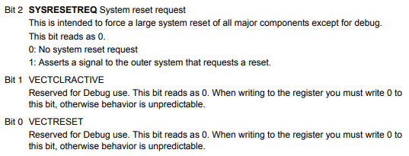

(ProgMan p. 134-135)

To write to this register, you must write 0x5FA to the VECTKEY field, otherwise the processor ignores the write.

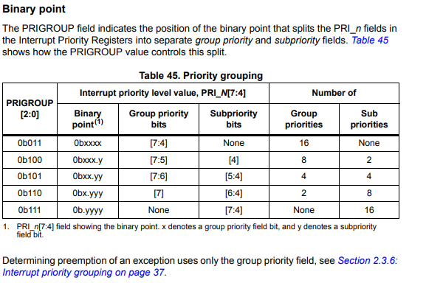

(ProgMan p. 135)

**NVIC**

